The Friends of Joseph M Demko is happy to present…
Our Farm to School fundraiser! There are 2 bundles to choose from.
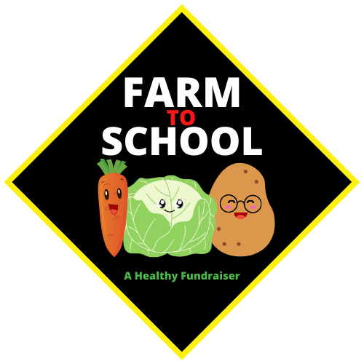
Order deadline is September 25th. Pickup will be at the school on October 5th.

VEGETABLE BUNDLE A - $15.00
- 2lbs carrots
- 5lbs red potatoes
- 2lbs yellow cooking onions

VEGETABLE BUNDLE B - $25.00
- 3lbs carrots
- 10lbs red potatoes
- 3lbs yellow cooking onions
- 1lb parsnips
- 1 head green cabbage
Select Joseph M Demko as your school when you order.
Order here: https://peakfarmtoschool.com/shop/buybundle
Thank you for your continued support!

